**Investment Strategy Analysis**

***Comparing Top Five (5) S&P 500 Companies to the Index***

# **Executive Summary**

This report presents a comprehensive investment strategy analysis comparing an equal-weighted portfolio of five leading S&P 500 companies—Apple, NVIDIA, Microsoft, Amazon, and Meta—against the S&P 500 index over a ten-year period from January 1, 2015, to December 31, 2024. The objective was to evaluate whether investing in a carefully selected stock portfolio could outperform a passive index fund, both in terms of raw and risk-adjusted returns.

Key Findings

Performance Superiority: The equal-weighted portfolio significantly outperformed the S&P 500 index. While the index yielded a cumulative return of approximately 1.24x, the portfolio achieved a staggering 60.69x return, driven largely by the exceptional performance of NVIDIA.

Risk-Adjusted Returns: Despite higher volatility, the portfolio demonstrated superior risk-adjusted performance. The Sharpe ratio for the portfolio was 1.24 compared to 0.51 for the index, indicating a 242% improvement in returns per unit of risk.

Correlation and Diversification: The selected stocks showed strong positive correlations with each other and the index, with the lowest correlation being 0.69 between Amazon and NVIDIA. This suggests a degree of diversification within the portfolio, albeit within a tech-heavy sector.

Market Trends Influence: The portfolio’s outperformance became more pronounced after 2020, coinciding with the surge in digital transformation, AI adoption, and e-commerce—sectors where the selected companies are dominant players.

While the analysis clearly demonstrates the potential for superior returns through strategic stock selection, it also underscores the difficulty of predicting such outcomes in advance. Warren Buffett’s advice to invest in index funds remains relevant for most investors, as the success of this portfolio was largely retrospective and benefited from hindsight. The findings highlight the trade-off between active and passive investing—greater potential returns versus simplicity and lower risk.

The study is limited by its narrow focus on five tech-centric companies, which may not reflect broader market dynamics. External factors such as economic cycles, geopolitical events, and data quality also introduce uncertainty. Additionally, the chosen time frame may not capture all market conditions, potentially skewing results.

The analysis concludes that while index funds offer stable and reliable returns, a well-researched and diversified portfolio of high-performing stocks can yield significantly higher returns, even after adjusting for risk. However, due to the unpredictability of markets and the expertise required for stock selection, index funds remain a prudent choice for the average investor.

**Table of Contents**

**Executive Summary** 2

**Introduction** 4

**Case Description** 4

**Details** 4

**Participants** 4

**Methodology** 5

**Data Collection** 5

**Data Analysis** 5

**Investment Simulation** 5

**Risk-Adjusted Performance** 5

**Analysis** 7

**Relationship Comparison** 7

**Performance Comparison** 8

**Risk-Adjusted Returns** 10

**Discussion** 11

**Interpretation** 11

**Conclusion** 12

**Recommendations** 12

**References** 14

**Appendices** 15

# **Introduction**

Investing in the stock market can be a daunting task for ordinary investors, particularly when it comes to selecting individual stocks and timing the market effectively. Warren Buffett, the renowned investor, has long advised that most people may struggle with these decisions and instead recommends investing in a fund—such as an index fund—as a more practical and reliable approach.

This report analyzes the performance of an equal-weighted investment in five leading S&P 500 companies (Apple, NVIDIA, Microsoft, Amazon, and Meta) from 2015 to 2024, comparing it to the overall performance of the S&P 500 index. Additionally, it evaluates risk-adjusted returns using the Sharpe ratio to determine whether investing in the index fund is worthwhile, and if not, what the opportunity cost might be.

# **Case Description**

## **Details**

The selected companies for this analysis are:

* Apple (AAPL)
* NVIDIA (NVDA)
* Microsoft (MSFT)
* Amazon (AMZN)
* Meta (META)

These companies are significant players in the S&P 500 index and have shown substantial growth over the years.

## **Participants**

The primary participants in this case study are ordinary investors who seek to maximize their returns while managing risk.

# **Methodology**

To evaluate the performance of the selected investment strategies, historical stock data was collected and analysed over a ten-year period from January 1, 2015, to December 31, 2024. The analysis focused on five leading S&P 500 companies: Apple (AAPL), NVIDIA (NVDA), Microsoft (MSFT), Amazon (AMZN), and Meta (META).

## **Data Collection**

* **Adjusted daily closing prices** for each stock and the S&P 500 index were sourced from *Investing.com.*
* The data was compiled and pre-processed using **Alteryx**, which facilitated the merging and cleaning of datasets.
* The cleaned dataset was exported as a CSV file for further analysis.

## **Data Analysis**

* The CSV file was imported into **Jupyter Notebook**, where Python was used for in-depth analysis.
* Key Python libraries included:
  + **Pandas** and **NumPy** for data manipulation and statistical calculations.
  + **Matplotlib** and **Seaborn** for data visualization and correlation analysis.

## **Investment Simulation**

* An initial investment of **$100,000** was equally distributed across the five selected stocks.
* The portfolio’s performance was tracked and compared to the S&P 500 index over the same period.
* Returns were normalized to allow for direct comparison between the portfolio and the index.

## **Risk-Adjusted Performance**

Mean Daily return



where Ri​ is the return on day i, and n is the total number of trading days.

Standard Deviation Daily return



This measures the volatility of returns over the period.

Sharpe Ratio



where:

* R*p*​ = mean return of the portfolio,
* R*f*​ = risk-free rate (approximated using the 10-year U.S. Treasury yield at 4.37%),
* σ = standard deviation of the portfolio’s excess return.

CumulativeReturn



# **Analysis**

## **Relationship Comparison**

The selected stocks represent five of the top-performing companies within the S&P 500 index, making it essential to understand the relationships among them and how each correlates with the index itself. *Figure 1* presents a pair plot illustrating the interrelationships between the stocks and the S&P 500. Overall, there is a clear positive correlation among the stocks and between each stock and the index.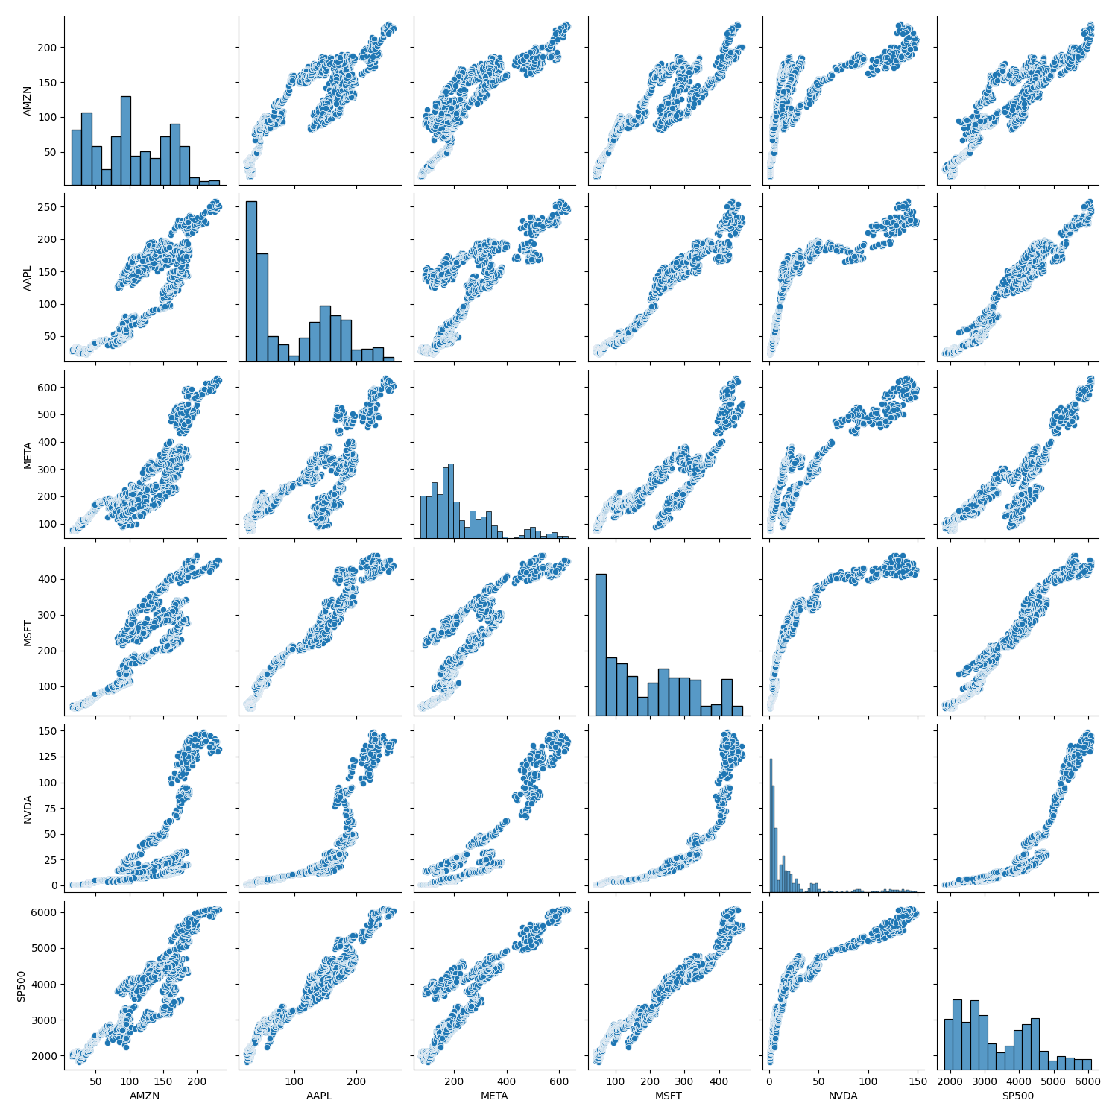*Figure 1*

*Figure 2* provides a heat map of the correlation coefficients. The weakest correlation among the selected stocks is between **Amazon** and **NVIDIA**, with a coefficient of **0.69**—a reasonable outcome given the distinct industries in which these companies operate. In contrast, the correlations between each stock and the S&P 500 index are notably stronger, with the lowest being **0.83** between **NVIDIA** and *the index.*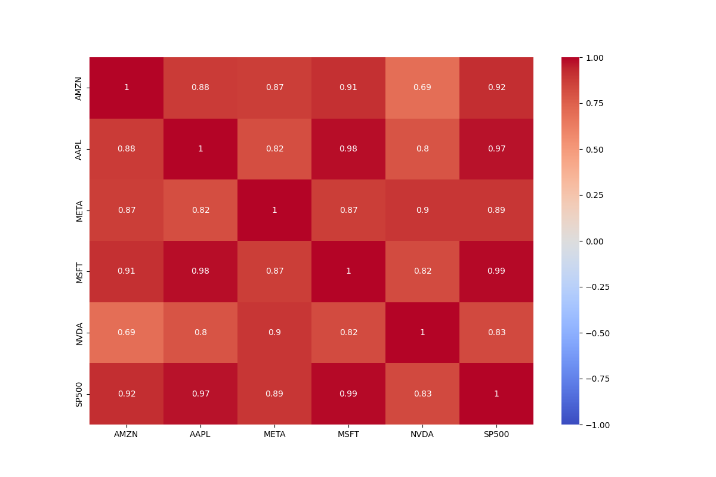

*Figure 2*

## **Performance Comparison**

The performance of the equal-weighted portfolio was evaluated against the S&P 500 index to determine which investment strategy delivered superior returns over the ten-year period under review.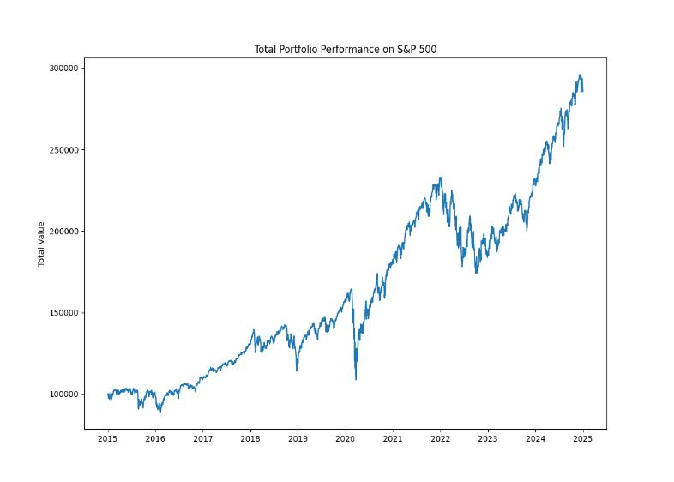

*Figure 3 Figure4*

As illustrated in *Figure 3* of the attached document, the normalized returns of the S&P 500 index were calculated and scaled based on the assumed investment amount. The results show a steady and consistent growth trajectory, reflecting the index’s long-term stability.*A graph of a graph
*

*Figure 5*

In contrast, the total returns from the equal-weighted portfolio of the top five stocks—Apple, NVIDIA, Microsoft, Amazon, and Meta demonstrated significantly higher performance, as shown in *Figure 4*. Notably, *Figure 5* highlights **NVIDIA** as the standout contributor, with returns far exceeding those of the other stocks, making it a clear outlier.

*Figure 6*

Further analysis in *Figure 6* reveals that the portfolio’s performance began to diverge sharply from the index after 2020. This widening gap can be attributed to accelerated growth in sectors such as e-commerce, social media, and artificial intelligence, where the selected companies hold dominant positions.

## **Risk-Adjusted Returns**

Using statistical and financial metrics is essential for quantifying the performance differences between the equal-weighted portfolio and the S&P 500 index fund. To assess the numerical impact of each investment strategy, the analysis incorporates key indicators such as **Cumulative Return** over the 10-year period, **Mean Daily Return**, **Standard Deviation of Daily Returns**, and the **Sharpe Ratio**.

The **Sharpe Ratio** is particularly valuable for evaluating **risk-adjusted returns**, as it accounts for both the return and the volatility of the portfolio. In this analysis, the **10-year U.S. Treasury yield**, currently at approximately **4.37% per annum**, is used as the **risk-free rate**. This rate is considered appropriate due to its long-term stability, high liquidity, widespread acceptance in financial modelling, and sensitivity to monetary policy changes.

|  |  |  |  |
| --- | --- | --- | --- |
| **Measure** | **S&P 500** | **Equal Weighted Portfolio** | **% Difference** |
| Cumulative Return | 1.236614011 | 60.687765 | 4,908% |
| Mean Daily Return | 0.000480904 | 0.001900959 | 395% |
| Standard Deviation Daily Return | 0.011230147 | 0.022865824 | 204% |
| Sharpe Ratio | 0.0321615 | 0.07789936 | 242% |
| Annualized Sharpe Ratio | 0.51054798 | 1.236614011 | 242% |

*Table 1*

As shown in *Table 1*, the summary analysis clearly demonstrates that the equal-weighted stock portfolio significantly outperformed the S&P 500 index. The portfolio achieved a **cumulative return more than 49 times greater** than that of the index. Furthermore, the **Sharpe Ratio**—a key measure of risk-adjusted performance indicates a **242% improvement** over the index.

*Figure 7 Figure 8*

This substantial margin can largely be attributed to the exceptional price growth of NVIDIA, which emerged as a major outlier in the portfolio. However, it’s important to note that this outperformance also reflects broader trends: the technology and online retail sectors have experienced unprecedented growth over the past five years, driven by advancements in artificial intelligence, cloud computing, and shifts in consumer behaviour.

# **Discussion**

## **Interpretation**

The analysis set out to determine whether investing in a low-cost, passive index fund like the S&P 500 is a better strategy for ordinary investors compared to selecting a concentrated portfolio of high-performing stocks. The results clearly show that the equal-weighted portfolio of Apple, NVIDIA, Microsoft, Amazon, and Meta significantly outperformed the index in both cumulative and risk-adjusted returns.

However, this outperformance must be viewed through a critical lens. The portfolio’s success was largely driven by exceptional growth in a few companies—most notably NVIDIA—whose rise was fuelled by transformative trends such as artificial intelligence, cloud computing, and e-commerce. These trends were not easily predictable a decade ago, and most retail investors would have found it difficult to identify and commit to these specific stocks with such conviction and consistency.

Moreover, while the portfolio delivered higher returns, it also came with increased volatility, as reflected in its higher standard deviation. This means that although the reward was greater, so was the risk—something that may not align with the risk tolerance of the average investor.

In essence, the analysis reinforces a key principle in investing: while active stock selection can yield extraordinary results, it requires foresight, discipline, and a high tolerance for risk. For most investors, especially those without the time or expertise to actively manage their portfolios, a diversified index fund remains a sound and practical choice.

**Limitations**

The case study analysis has several limitations that may affect the outcome. Firstly, the findings are specific to the performance of five selected S&P 500 companies (Apple, NVIDIA, Microsoft, Amazon, Meta) and may not be generalizable to other companies or sectors. This narrow focus limits the ability to apply the conclusions to broader market trends or different investment periods. Additionally, external factors such as market volatility, economic changes, and geopolitical events can significantly impact stock performance, adding uncertainty to the results. The analysis also relies on the availability and quality of historical stock data, and any gaps or inaccuracies can affect the validity of the findings. Furthermore, the chosen time frame might not capture all relevant market cycles, potentially skewing the results. By acknowledging these limitations, the analysis can be approached with a more balanced and critical perspective.

# **Conclusion**

This investment strategy analysis reveals that an equal-weighted portfolio of five top-performing S&P 500 companies—Apple, NVIDIA, Microsoft, Amazon, and Meta—substantially outperformed the S&P 500 index over the 2015–2024 period. The portfolio not only delivered significantly higher cumulative returns but also demonstrated superior risk-adjusted performance, as evidenced by a Sharpe ratio more than double that of the index.

The findings highlight the potential of strategic stock selection in achieving exceptional returns. However, this success is largely retrospective and benefits from hindsight. The analysis also underscores the volatility and risk associated with concentrated investments in specific sectors, particularly technology.

Despite the portfolio’s impressive performance, the broader applicability of this strategy is limited by market unpredictability, the difficulty of consistently identifying outperforming stocks, and the influence of macroeconomic and geopolitical factors.

# **Recommendations**

1. **For Ordinary Investors**:  
   Index funds remain a reliable and practical investment vehicle. They offer broad market exposure, lower risk, and minimal management effort—ideal for long-term wealth accumulation without the need for active stock picking.
2. **For Experienced or Informed Investors**:  
   A carefully curated portfolio of high-growth stocks can yield superior returns, especially when supported by thorough research and a long-term investment horizon. However, this approach requires a strong understanding of market trends, risk tolerance, and the ability to withstand volatility.
3. **Diversification is Key**:  
   Even within a high-performing portfolio, diversification across industries and asset classes can help mitigate risk and enhance stability.
4. **Reassess Regularly**:  
   Market dynamics evolve. Investors should periodically review and adjust their portfolios to align with changing economic conditions, technological advancements, and personal financial goals.

# **References**

* [www.investing.com](http://www.investing.com)
* <https://learn.corporatefinanceinstitute.com/auth/login>



# **Appendices**

Figure 1.1

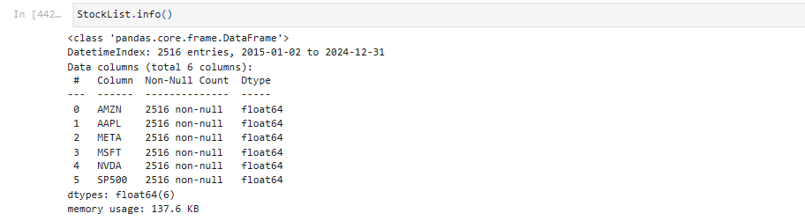

Figure 1.2

Figure 1.3

Figure 1.4

Figure 1.5

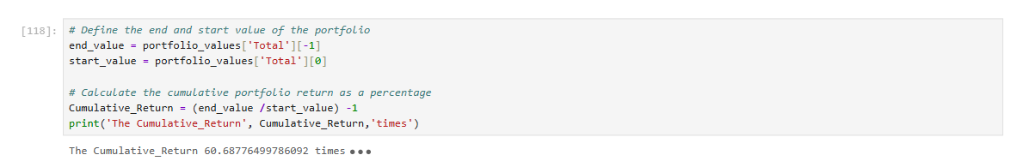

Figure 1.6

Figure 1.7

Figure 1.8

Figure 1.9

Figure 1.10

